**Question:**

* Outline the steps you would take to convert this java app into a Helm package that can be easily deployed on a Kubernetes cluster.
* What are the key considerations and best practices you need to keep in mind while packaging this app as a Helm chart, keeping in mind the eventual goal of making the company's full-fledged e-commerce platform Kubernetes-ready?
* How would you ensure that the Helm chart is flexible enough to work seamlessly on any cloud-managed Kubernetes marketplace?
* Once the Helm chart is ready, what will be your approach to test it for different scenarios to ensure its proper functioning in diverse environments

Screenshots of kubectl get svc

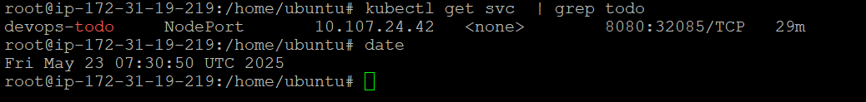

Screenshot of yaml fiel which shows image and tag , port (no liveliness probe) of values.yaml

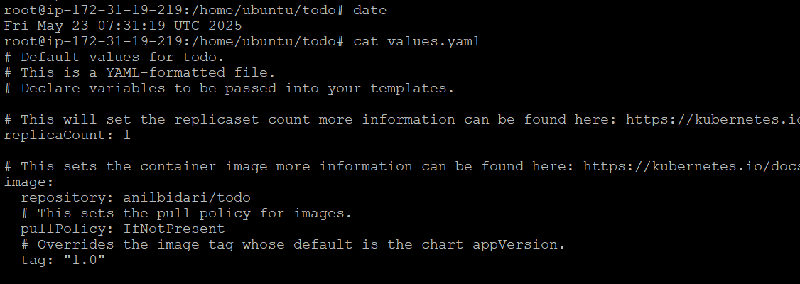

port (no liveliness probe)

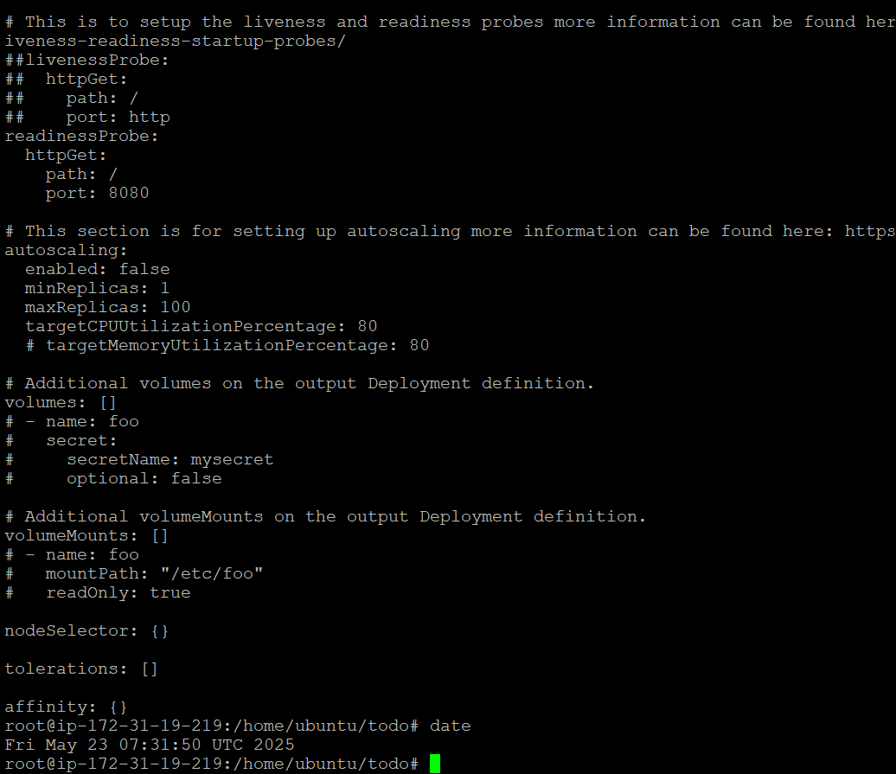

url screenshot- app showing up on browser ( IP:nodeport)

